13+ Entrance Examination
Mathematics
Specimen Paper

Time allowed: 40 minutes
Answer all questions in the spaces provided.
Calculators may not be used.

Q1.Work out which distance is longer,
20% of 320 miles or of 130 miles.
You must show your working.
..................................................................................................................................
..................................................................................................................................
..................................................................................................................................
..................................................................................................................................
..................................................................................................................................
..................................................................................................................................
Answer ......................................................................
(Total 4 marks)

Q2.(a) Simplify fully 4a − 3a + 2b − 8b
.........................................................................................................................
.........................................................................................................................
.........................................................................................................................
Answer ......................................................................
(2)

(b) Factorize m² − 2m
Answer ......................................................................
(1)

(c) Multiply out 5x(x − 3)
.........................................................................................................................
Answer ......................................................................
(2)
(Total 5 marks)

Q3.
An ordinary fair dice is rolled.
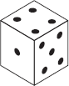
(a) Complete the tree diagram for the dice landing on 4
First spin Second spin
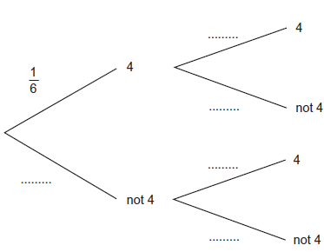
(1)

(b) Work out the probability of the dice landing on 4 both times.
..........................................................................................................................
..........................................................................................................................
Answer ......................................................................
(2)
(Total 3 marks)

Q4.
Here is a Venn diagram.
It shows information about the number of students who have a laptop or a TV.
Set L represents students with a laptop.
Set T represents students with a TV.
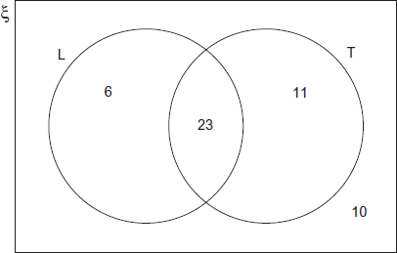
There are 50 students altogether.
A student is chosen at random.

(a) Work out the probability that the student has a laptop.
Answer ......................................................................
(1)

(b) Work out the probability that the student has a laptop and a TV.
Answer ......................................................................
(1)

(c) Complete the sentence to make it true.
The probability that the student .........................................................................................
.............................................................................................. is
(1)
(Total 3 marks)

Q5.
Which of these is the net of a cube?
Circle the correct letter.
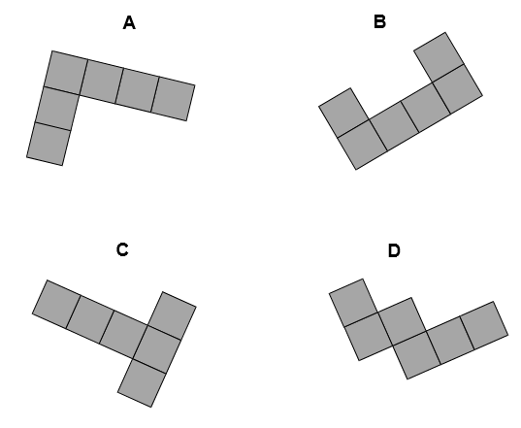
(Total 1 mark)

Q6. Here are three expressions.
a − b ab
When a = 2 and b = −6 which expression has the lowest (furthest left on the number line) value?
You must show your working.
..................................................................................................................................
..................................................................................................................................
..................................................................................................................................
..................................................................................................................................
Answer ............................................
(Total 2 marks)
Q7.
Sam wants to buy a camera for £345
He has already saved £96
Each week
his pay is £80
he saves 30% of this pay.
How many more weeks must he save?
..................................................................................................................................
..................................................................................................................................
..................................................................................................................................
..................................................................................................................................
..................................................................................................................................
Answer ............................................ weeks
(Total 4 marks)

Q8.
The nth term of a sequence is 2n + 1
The nth term of a different sequence is 3n − 1
Work out the three numbers that are
in both sequences
and
between 20 and 40
..................................................................................................................................
..................................................................................................................................
..................................................................................................................................
..................................................................................................................................
..................................................................................................................................
..................................................................................................................................
..................................................................................................................................
Answer ..........................., ..........................., ...........................
(Total 3 marks)

Q9.Here is a map of Sardinia.
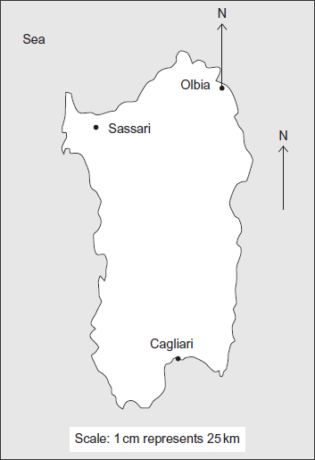
(a) Work out the actual distance between Cagliari and Sassari.
.........................................................................................................................
.........................................................................................................................
.........................................................................................................................
.........................................................................................................................
Answer ...................................................................... km
(3)

(b) Mario’s favorite point along the whole coast is on a bearing of 165° from Olbia.
Draw this bearing and mark with a cross the position of this location.
(2)
(Total 5 marks)

Q10.(a) Work out the Highest Common Factor (HCF) of 24 and 42
.........................................................................................................................
.........................................................................................................................
Answer ......................................................................
(2)

(b) As a product of prime factors 36 = 2² × 3²
Write 48 as a product of prime factors.
.........................................................................................................................
.........................................................................................................................
Answer ......................................................................
(2)
(Total 4 marks)

Q11.(a) The table shows the masses of planets in the form a × 10²⁴ kg

 | Planet | Mass (kg)
 | Mercury | 0.330 × 10²⁴
 | Venus | 4.87 × 10²⁴
 | Mars | 0.642 × 10²⁴
 | Jupiter | 1900 × 10²⁴
 | Saturn | 568 × 10²⁴

Write the mass of Jupiter in kilograms.
Give your answer in standard form.
..........................................................................................................................
Answer ......................................................................
(1)

(b) The mass of the Earth is 5.97 × 10²⁴ kg
The volume of the Earth is 1.02 × 10²¹ m³
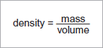
Calculate roughly the density of the Earth.
Give your answer to an appropriate degree of accuracy.
..........................................................................................................................
..........................................................................................................................
..........................................................................................................................
..........................................................................................................................
Answer ...................................................................... kg / m³
(3)
(Total 4 marks)

Q12.
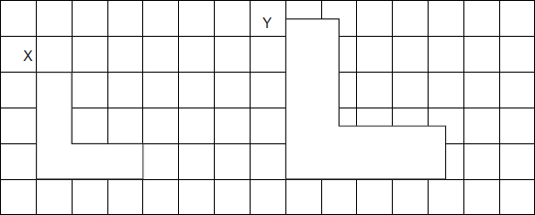
(a) Shape Y is an enlargement of shape X.
What is the scale factor of the enlargement?
Answer ......................................................................
(1)
(b) Shape X has a perimeter of 12 cm.
Work out the perimeter of shape Y.
Answer ................................................................... cm
(1)
(Total 2 marks)

Q13.A and B are two towns.
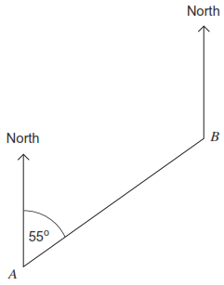
Here is a formula for working out the bearing of A from B.
T = F + 180°
where T is the bearing of A from B
and F is the bearing of B from A

(a) Use the diagram and the formula to work out the bearing of A from B.
........................................................................................................................
........................................................................................................................
Answer ...................................................................°
(2)

(b) Give a reason why the formula can only be used for 0° < F ≤ 180°
........................................................................................................................
........................................................................................................................
(1)

(c) The bearing of C from D is 342°.
Work out the bearing of D from C.
........................................................................................................................
........................................................................................................................
Answer ...................................................................°
(2)
(Total 5 marks)

