11+ Entrance Examination MATHEMATICS
Specimen Paper

Time allowed: 1 hour
Marks available: 90 marks

Answer all questions in the spaces provided. Calculators may not be used.

NAME:

DATE OF BIRTH:

1. | Answer | (2)
  7401 + 1649
2. | 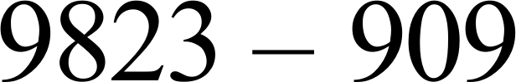  Answer | (2)
3. | 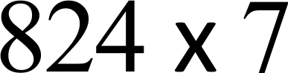  Answer | (2)
4. | 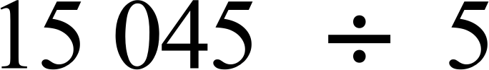  Answer | (2)
5. | Write down the number which is 9 more than eight hundred and  Ninety-six.  Answer_____________ | (2)

6. | Fill in the missing numbers to make the sum correct:  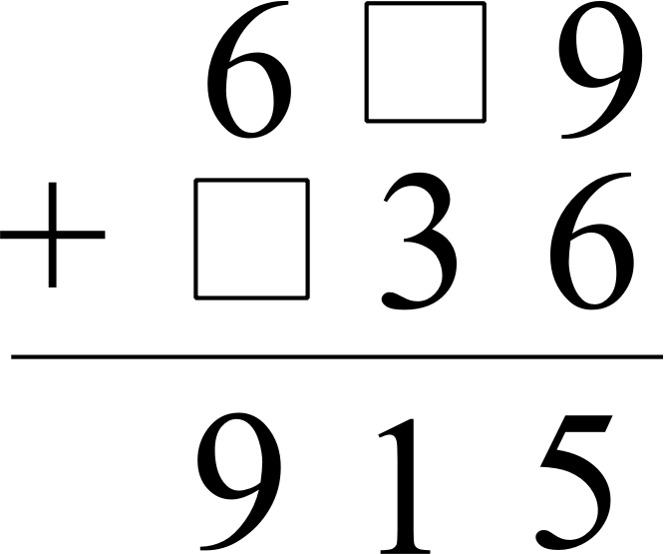
 | (2)
7. | A rugby squad has 36 players. Four ninths of them did not play in  the first two games of the season. How many played in at least one of these first two matches?  Answer
 | (2)
8. | Jermaine buys 9 packets of throat lozenges for £5.85. How much  would 4 packets cost him?  Answer
 | (2)
9. | Fill in the numbers in each sequence:  - 1, 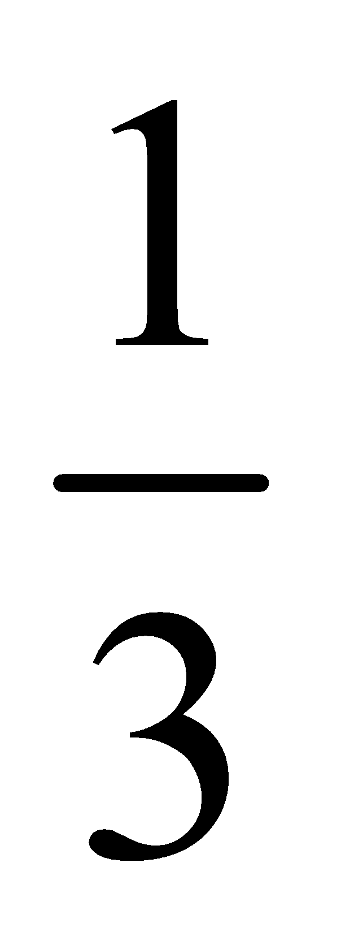, 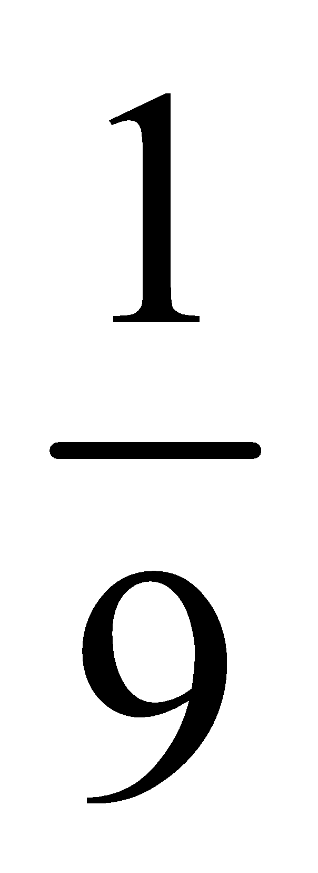, 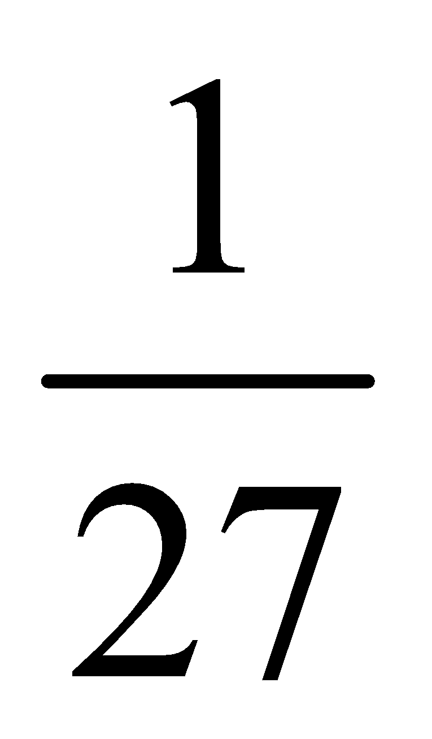, ,  - 3.5, -0.5, -4.5, -8.5, ,  - 1, 1, 2, 3, 5, ,
 | (6)

10. | A chocolate bar costs 62p. How many can Sophie buy with a £5 note?  Answer
 | (2)
11. |   A man is standing facing East. Through how many degrees does he rotate to end up facing South-West if he rotates clockwise?  Answer
 | (2)
12. | A ruler is marked as below:  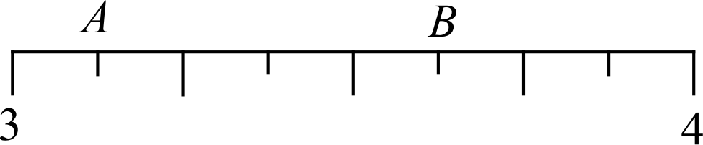  - What is the value of the marker at A? Express your answer as a fraction?  Answer  - Write the value of the marker at B as a decimal:  Answer
 | (3)

13. | 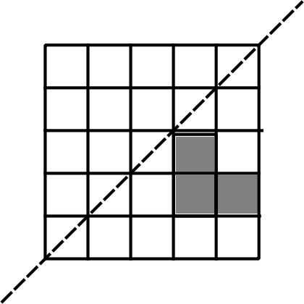  - Reflect the shaded shape in the mirror line on the diagram above.  - If each small square has side length 1cm, what is the area of the shape before reflection?  Answer cm²  - What is the perimeter of the shape before reflection?  Answer cm
 |  | (3)
14. | A film begins and ends at the following times:  START: 16:33  FINISH: 19:09  How long did the film last?  Answer hours minutes
 |  | (2)
15. | Complete the calculations below:  - 251.9 x 100 =  - ÷ 1000 = 2.03
 |  | (2)

16. | Write the missing sign (=, < or >) in the box.  17 x 3 25 x 2
 | (1)
17. | Which number between 60 and 80 is both a multiple of 3 and 8?  Answer
 | (2)
18. | Emily thinks of her favourite number. She multiplies it by by 2,  subtracts 5 and gets 17.  What is Emily’s favourite number?  Answer
 | (2)
19. | - Write $\frac{3}{5}$ as a decimal.  Answer  - Write 0.85 as a fraction in lowest terms.  Answer  - What is $\frac{8}{24}$ as a fraction in lowest terms?  Answer  - Which is larger: $\frac{8}{24}$ or $\frac{1}{4}$ ?  Answer
 | (4)

20. | Cyrus has five number cards:  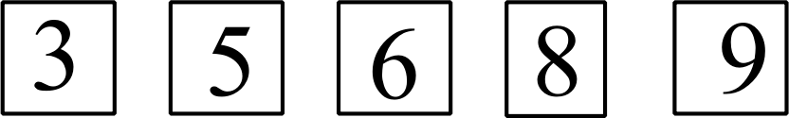  He picks three cards to form a 3-digit number. What cards could be picked to find:  - An even number?    - An odd number?  - A number divisible by 5?  His friend, Kevin, then asks him to choose the following from the five numbers:  - A two-digit prime number:    - A four-digit number divisible by 4:  
 |  | (5)
21. | Find the missing digits to make the calculation correct:  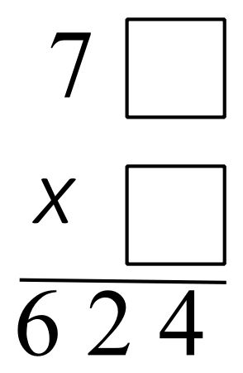  7
 |  | (2)

- Mrs Walters asked all the children in Year 6 if they play tennis. The table below shows some of the results.

 | Play tennis | Do not play tennis | Total
Class 6A | 14 |  | 20
Class 6B |  | 8
Total |  | 14 | 44

  - How many children are there in class 6A?

Answer
  - Complete the table.

  - What fraction of the children who don’t play tennis are in class 6B?
(6)

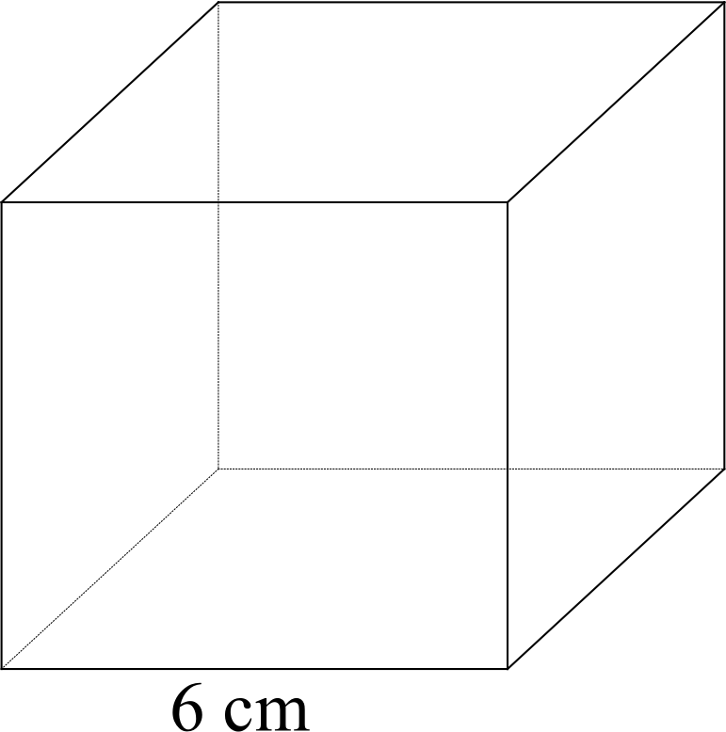
- Here is a cube of sides 6cm long.

Complete each sentence by writing
the correct number in the space provided.

  - A cube has vertices.
Answer

  - The volume of the cube shown is cm³.

  - Multiplying the number of faces by the number of edges gives a product of __________.

 | (d) A cuboid has the same volume as the cube shown. What could  its length, width and height be?  Answer , and | (5)
24. | Shade $\frac{2}{3}$ of this shape.  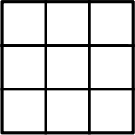
 |  | (1)
25. | Joanna and Suzanne set their watches to sound the alarm at  6.15am. Joannna’s alarm then sounds every 8 minutes. Suzanne’s alarm then sounds every five minutes.  At what time will the alarms next chime at the same time?  Answer
 |  | (2)
26. | 125 x 250 = 31250  Use this calculation to work out:  - 1.25 x 250 =  - 31250 ÷ 250 =  - 1250 x 2.5 =
 |  | (3)
27. | 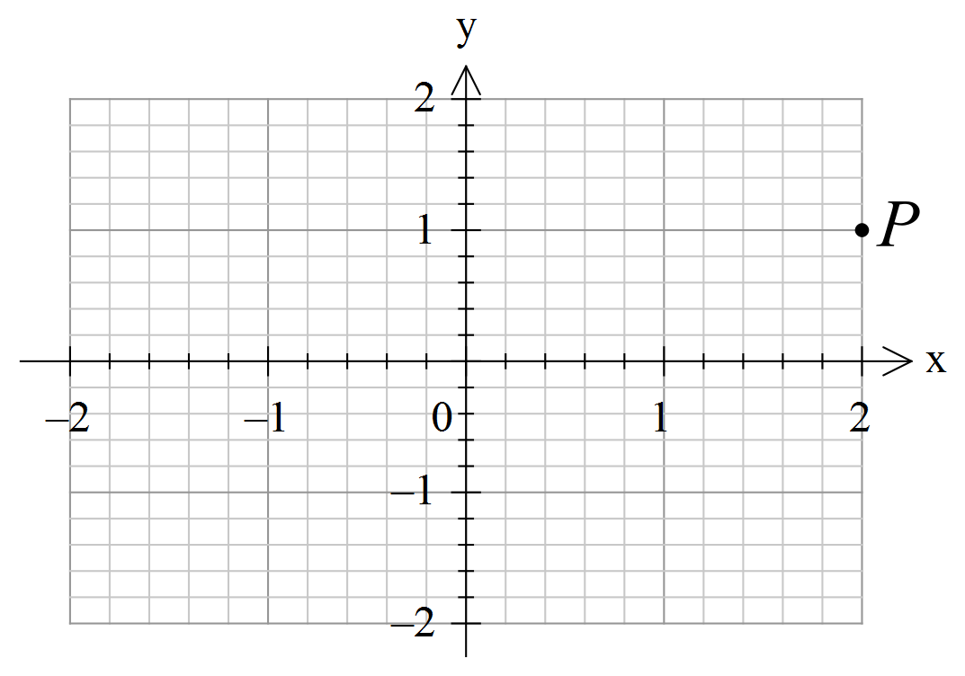  Write down the coordinates of P: ( , )
 |  | (1)
28. | 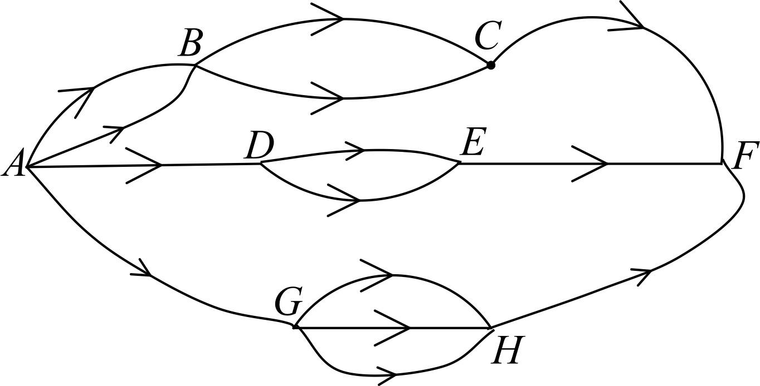  Only going from left to right in the direction of the arrows,  - How many routes are there from A to C?  Answer  - How many routes are there from A to E?  Answer

- How many routes are there from A to H?

Answer

- How many routes are there in total from A to F?

Answer
 | (4)
29. | Four years ago, the combined age of three children was 24 years.  What will their combined age be in two years’ time?  Answer
 | (2)
30. | Arrange the letters for each of these events in order of likelihood, starting with the least likely.  A Rolling two dice and getting two sixes;  B That a person chosen at random was born on a Friday;  C Rolling a dice and getting a three;  D The last digit of a randomly chosen telephone number is not 4.  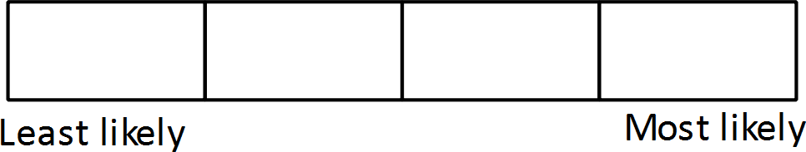  (4)

31. | Three pet rabbits cost £19.70. The second rabbit costs £2 more than the first. The third rabbit costs 80p less than the second. What is the cost of the first rabbit?  Answer £ :
 |  | (3)
32. | In the table below, each of the letters has a different value. Use the sum of each row and column (shown) to find the value of each letter.  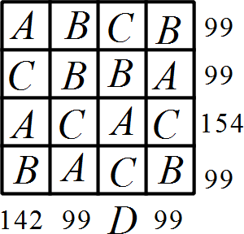  A = ; B = ; C = ; D =
 |  | (4)
 | A mathematical operation, denoted by the symbol ◊, is defined such that: a ◊ b = 3a – 2b.  - What is the value of 5 ◊ 2?  Answer  - Solve the equation:  y ◊ 6 = 15  y = | (3)

END OF PAPER

